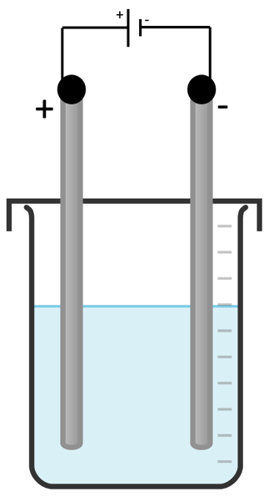
Electrolysis Apparatus
Electrolysis Apparatus
Electrolysis Apparatus
Electrolysis Apparatus
Electrolysis Apparatus
Electrolysis Apparatus

